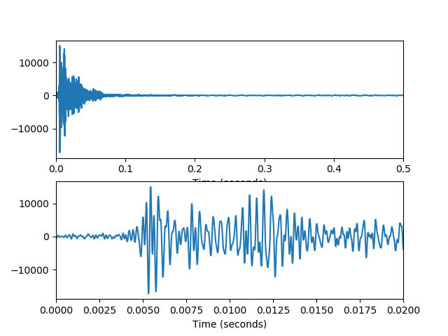

Fig 1 room1 response

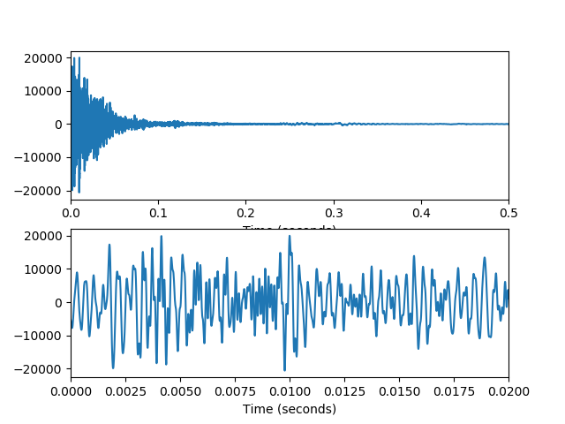

Fig 2 little room response

There is some difference between early returns and reverberation. Early returns are a few reflexes in the early time of the audio wave. But reverberation is the voice generate from which reflection wave overlapping with the audio wave.

In Fig 1, which was tested in a larger room than the test in Fig2, show that the audio wave has less noises and the room response 1 is cleaner than the room response 2 in a little room because the sound wave has a smaller number of times to be reflected. In a short time, the room response will nearly decline to zero.

In Fig2, the sound wave contains more noises and has more overlapping than Fig 1. Besides, the room response is blur than the Fig 1, and need more time to decline to zero.